Shell – Final Case Study Assessment

RUT CHOLERA

Emp code 655095

**STEP1: AZURE VM CONFIGURATION:**

Created a virtual machine, zone is US West2, using a standard hdd.

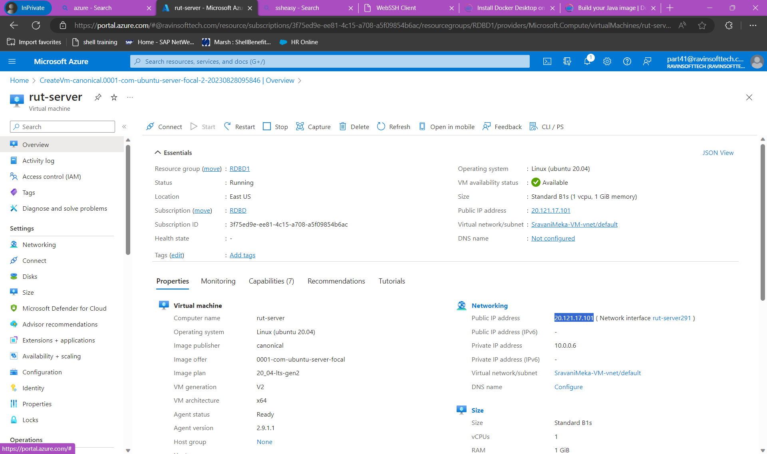

Creating repository on docker

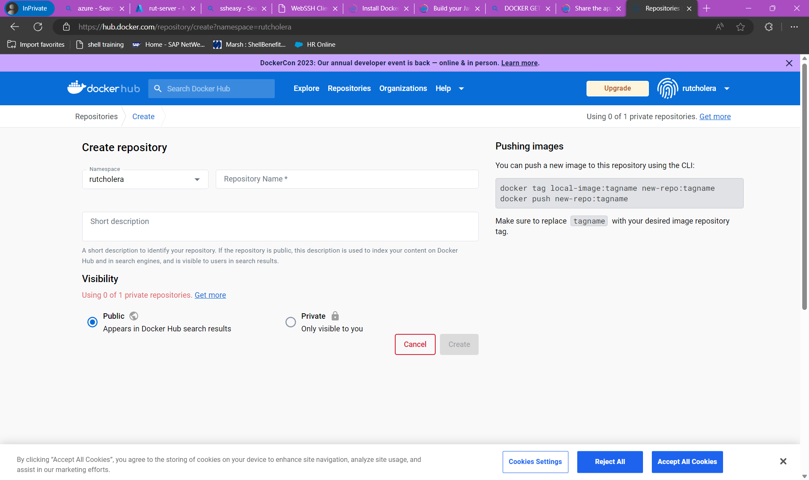

While installing maven we encountered that our machine has java 11 but we needed java 17.

The command to install maven is**-** *sudo apt install maven*

**STEP 2: DOCKER CONTAINERIZATION**

**Installing docker and Creating a java image**

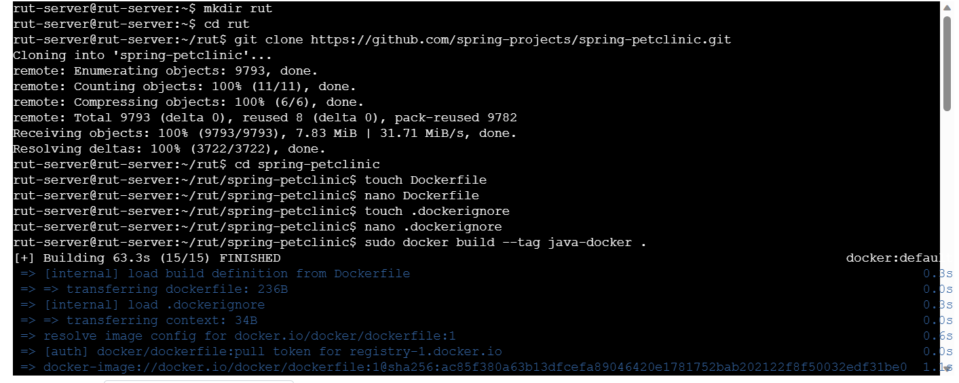

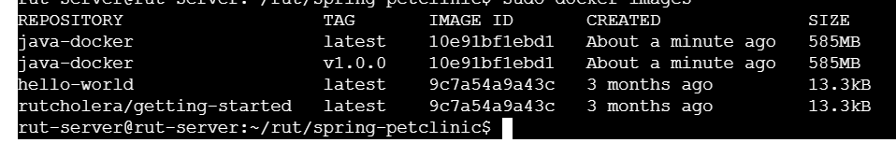

Removing docker image

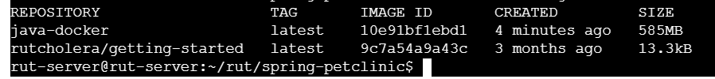

**Successfully pushed docker image**

The commands to execute is:

* cls
* clear
* sudo apt update
* sudo apt install git
* sudo apt install maven
* sudo apt update
* sudo apt-get install ca-certificates curl gnupg
* sudo install -m 0755 -d /etc/apt/keyrings
* curl -fsSL https://download.docker.com/linux/ubuntu/gpg | sudo gpg --dearmor -o /etc/apt/keyrings/docker.gpg
* sudo chmod a+r /etc/apt/keyrings/docker.gpg
* echo "deb [arch="$(dpkg --print-architecture)" signed-by=/etc/apt/keyrings/docker.gpg] https://download.docker.com/linux/ubuntu \
* "$(. /etc/os-release && echo "$VERSION_CODENAME")" stable" | sudo tee/etc/apt/sources.list.d/docker.list > /dev/null
* sudo apt-get update
* sudo apt-get install docker-ce docker-ce-cli containerd.io docker-buildx-plugin docker-compose-plugin
* sudo docker run hello-world
* systemctl status docker
* git clone https://github.com/hrb1989/shell_7_foundation_Java_Spring.git
* cd shell_7_foundation_Java_Spring
* mvn install -DskipTests
* sudo apt install -y openjdk-17-jdk
* mvn install -DskipTests
* docker build -t <name> -f /home/azureuser/shell_7_foundation_Java_Spring/Dockerfile
* Dockerfile
* docker build --tag rutcholera-docker:latest .
* sudo docker build --tag rutcholera-docker:latest .
* sudo docker login
* sudo docker images
* sudo docker tag rutcholera-docker:latest rutcholera/rutcholera-docker
* sudo docker push rutcholera/rutcholera-docker

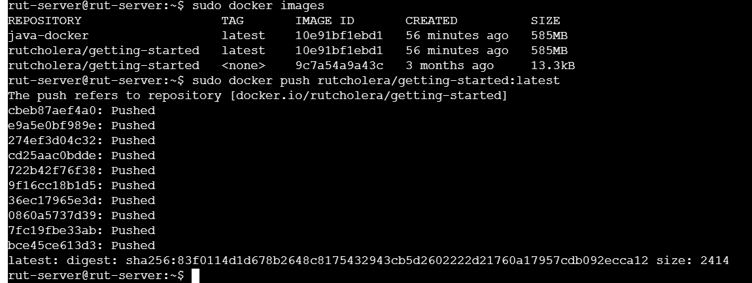

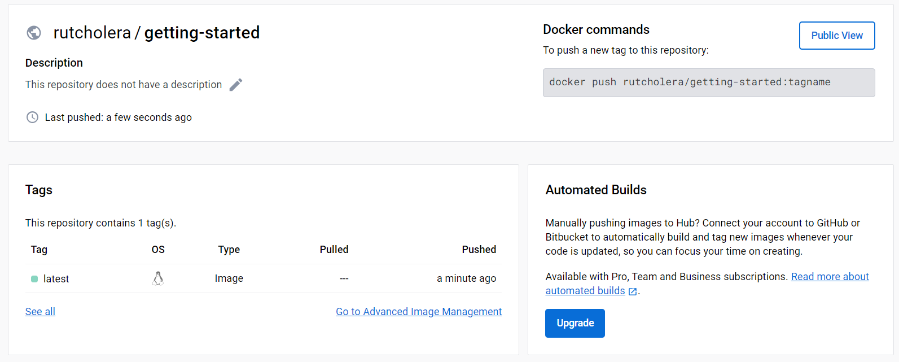

STEP 3: Creating web apps

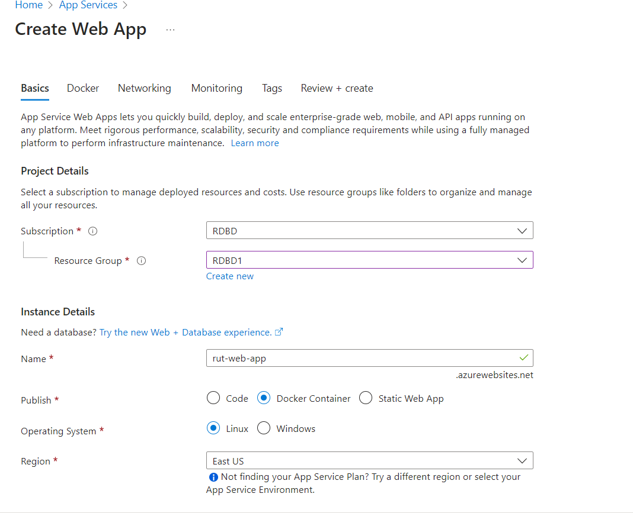

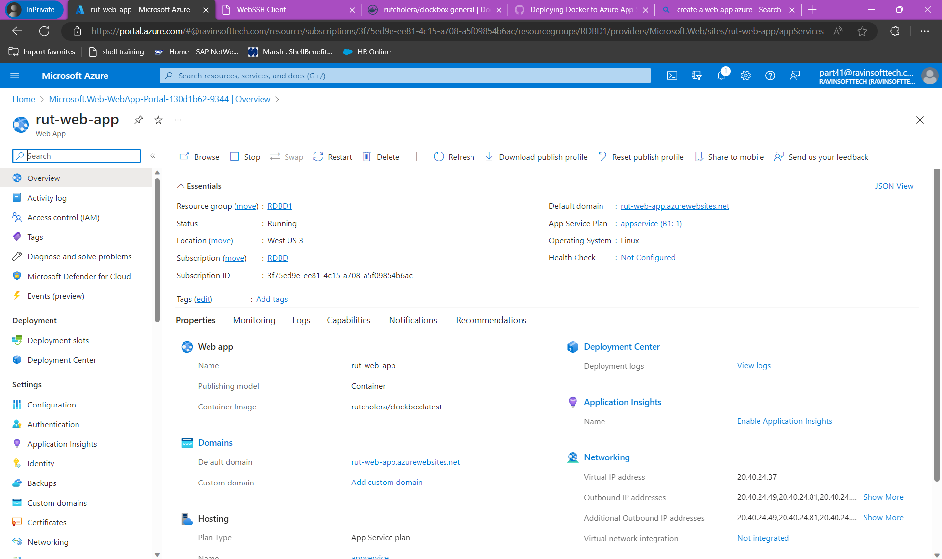

Launching web app

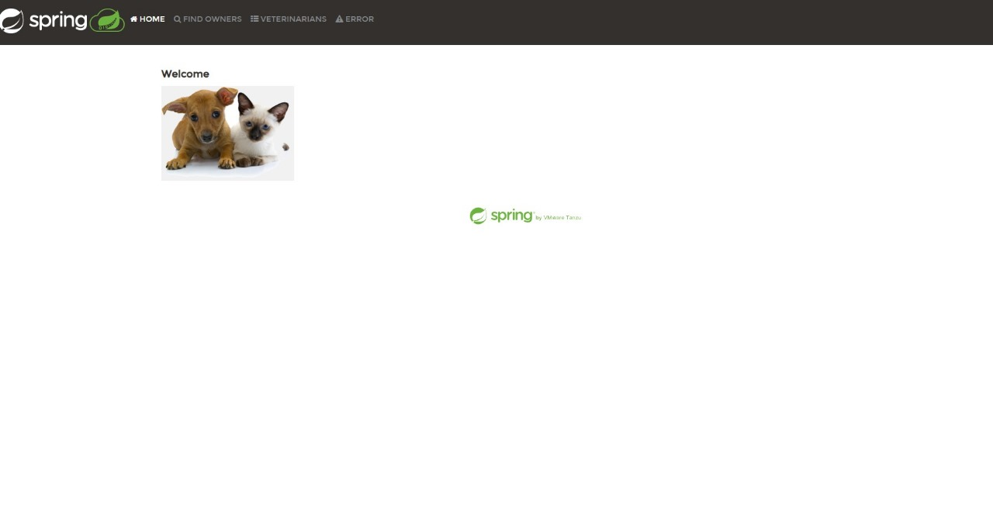

**STEP 4: CONTINUOUS INTEGRATION/GITHUB ACTIONS**

**Setting up and using Docker GitHub Actions for building Docker images, and pushing images to Docker Hub**

Creating GitHub repo and adding secrets for the repo

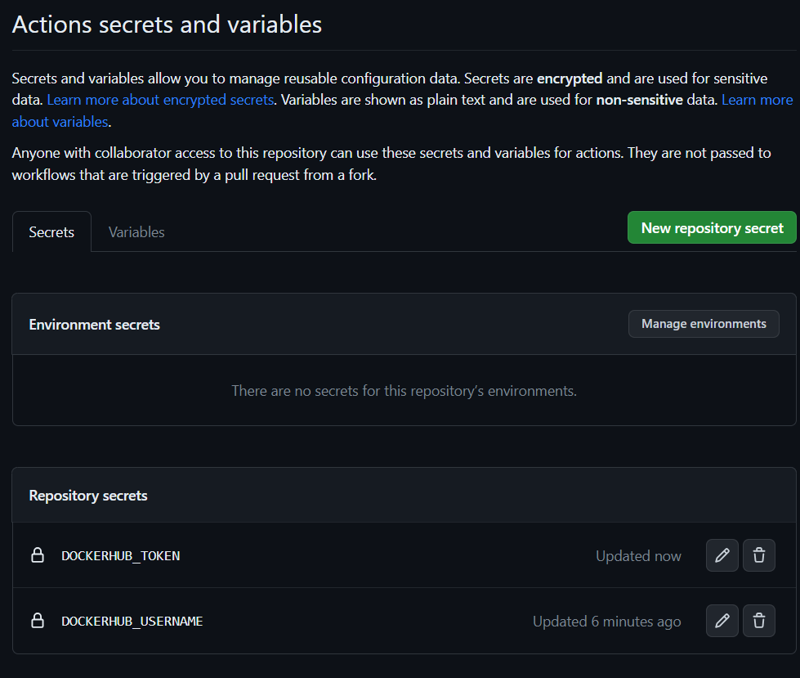

Repo added to Docker hub.

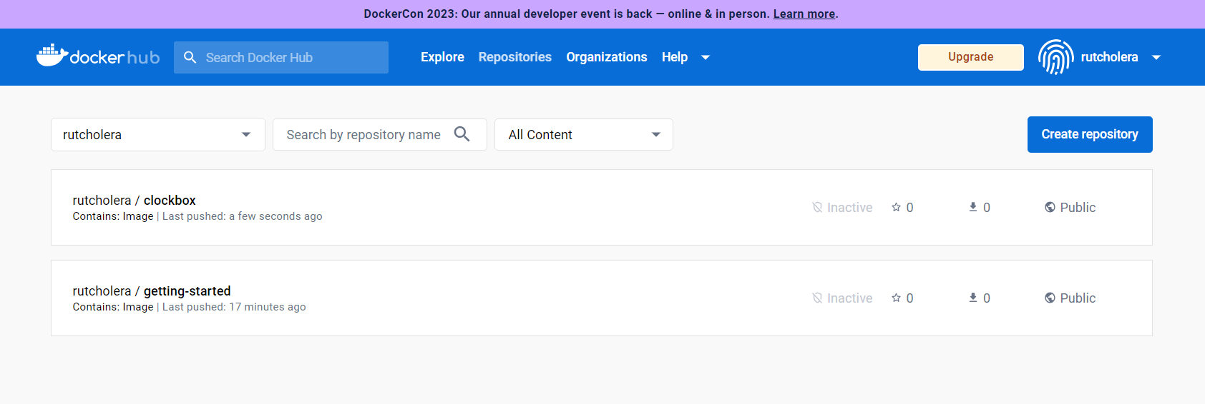

OUTCOME:

In today’s case study we learnt:

* how to create a virtual machine
* basics of docker
* creating a repo on docker
* creating java images and adding them on docker
* creating web apps
* linking web app to docker
* hosting and deploying of webapp
* doing continuous integrations
* doing GitHub actions, adding secrets on repo